VAPT PoC Report: SSRF Exploitation
Step 1: Login and open any product page.
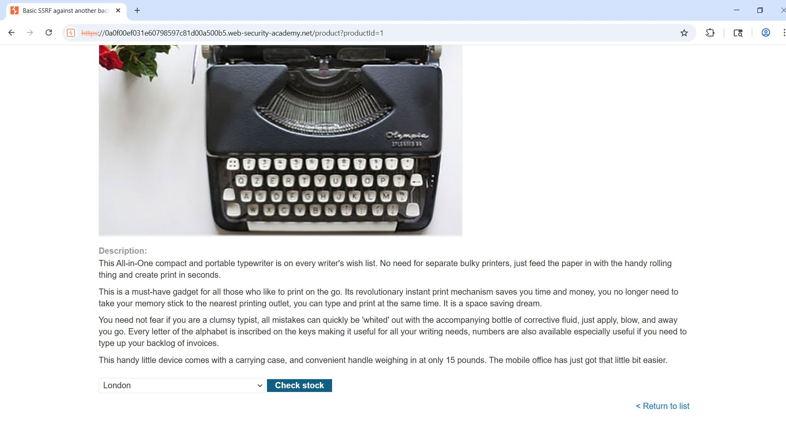
Step 2: Click 'Check Stock' and intercept request in Burp Suite.

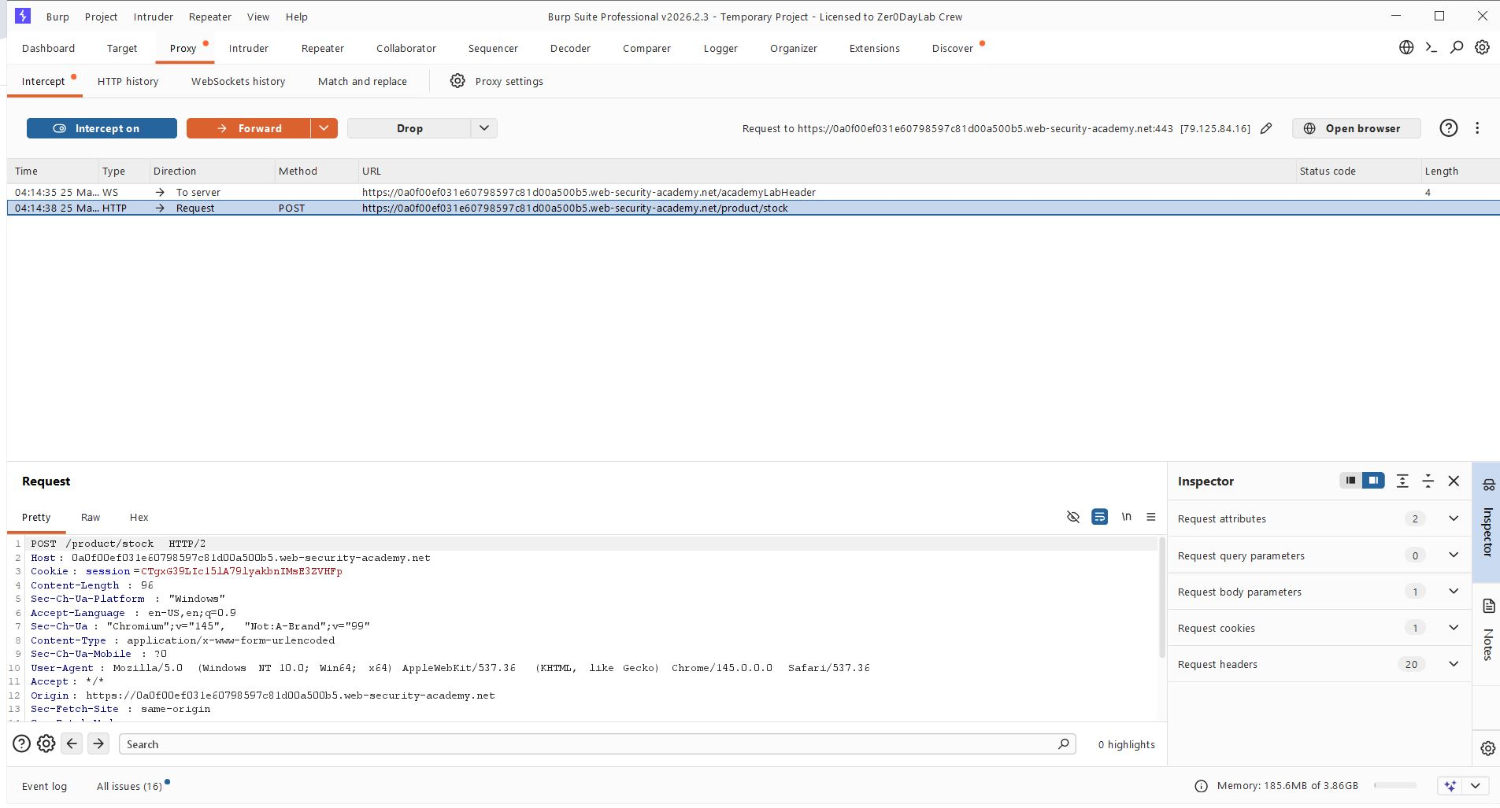

Step 3: Send request to Intruder and Mark last octet as payload (§). Set payload type Numbers (1 to 255).

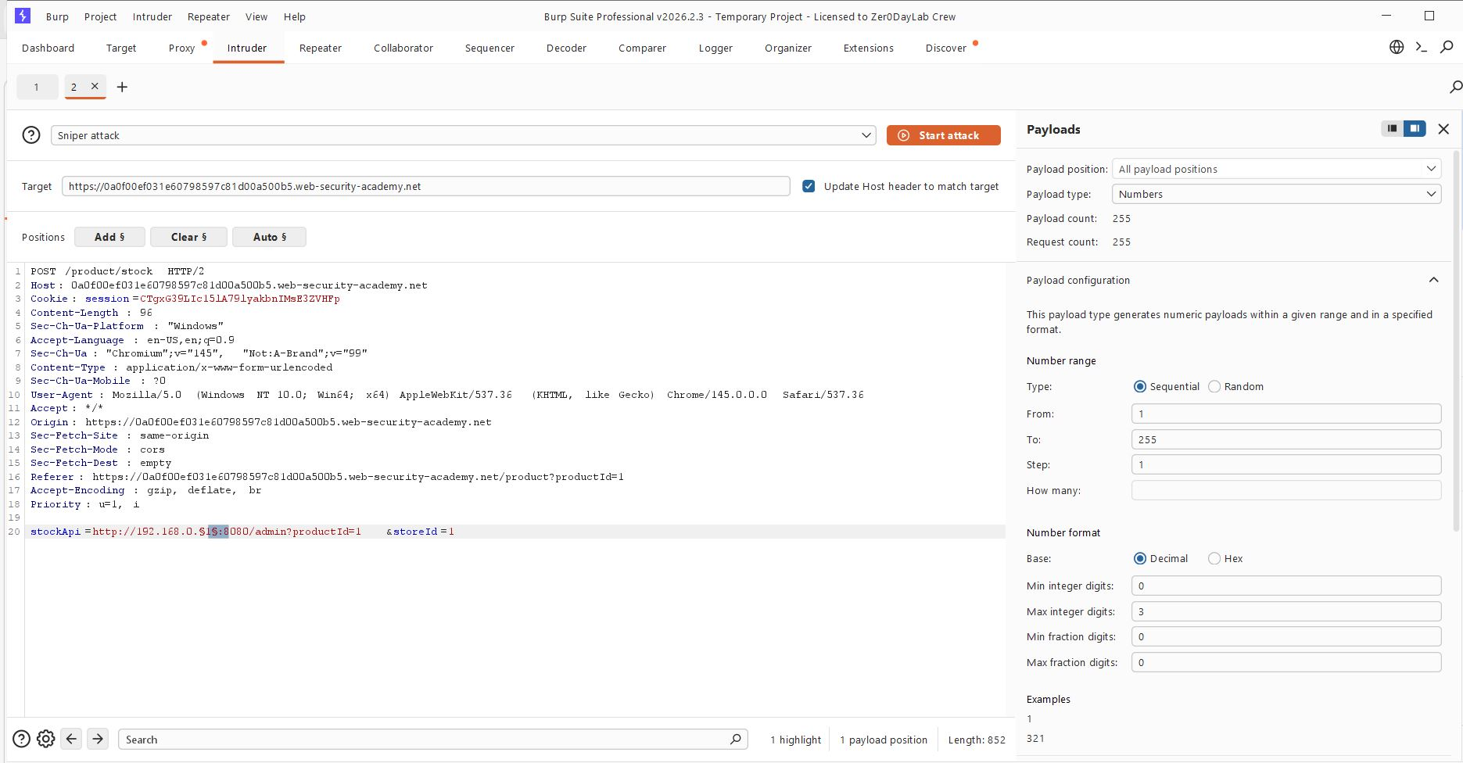
Step 4: Send that request to Repeater. Change stock Api to http://192.168.0.1:8080/admin
Replace them with the http://192.168.0.174/admin?productId=1
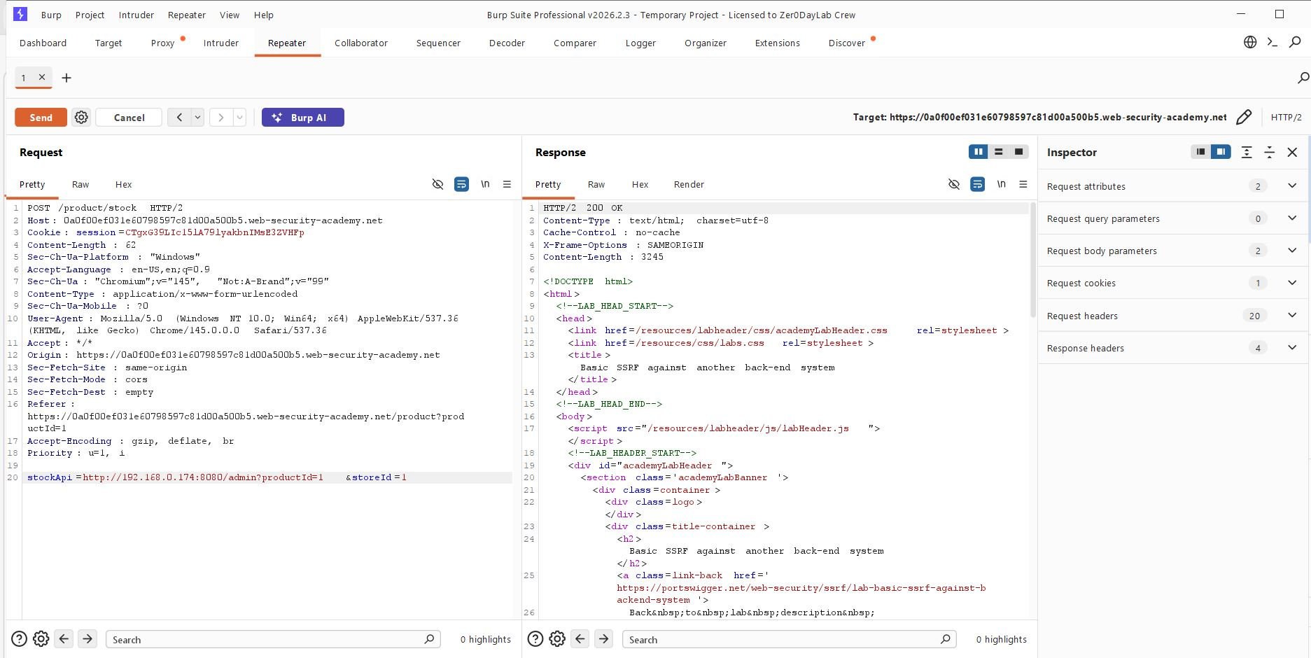

Step 5: Start attack and find 200 OK response.
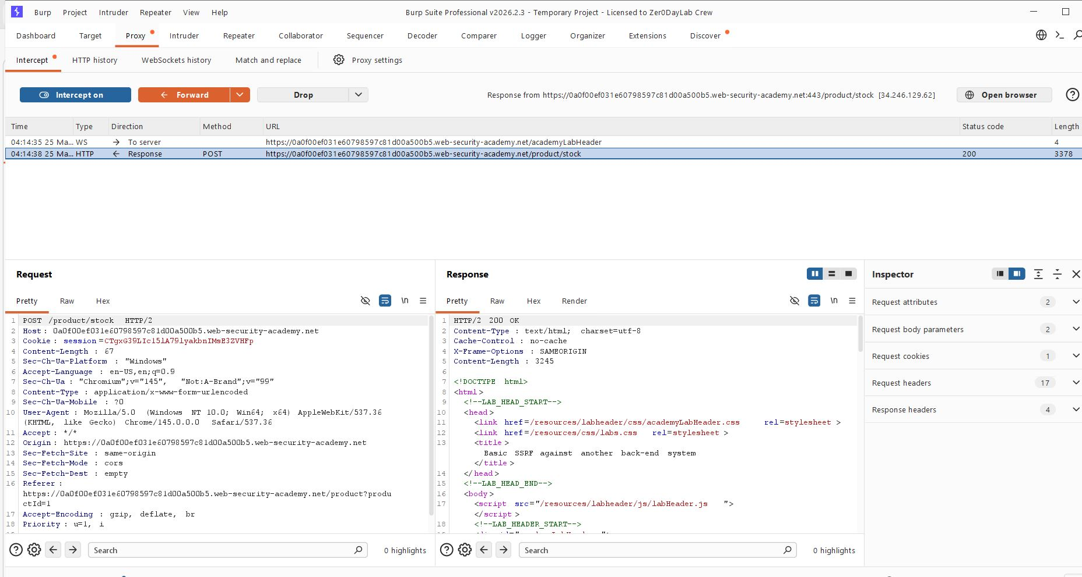
Step 6: - Change path to /admin/delete?username=carlos the user appear delete the carlo user.

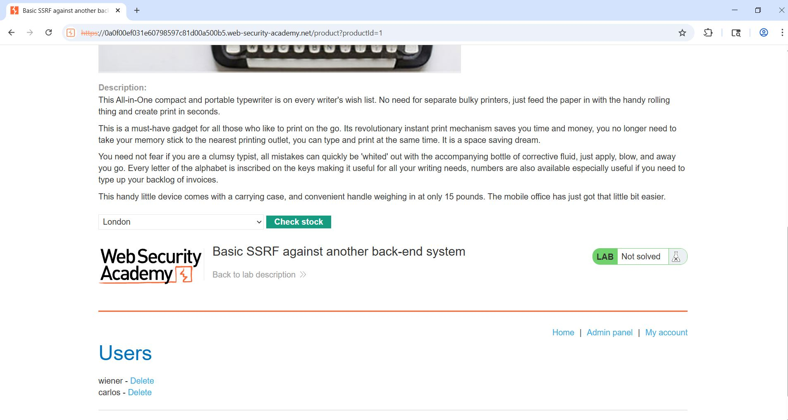

Lab 7: -Lab solve Successfully.
